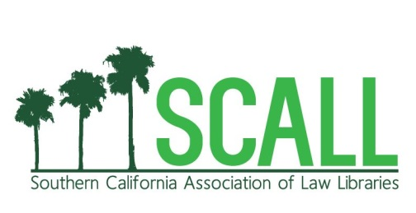 | Southern California Association  of Law Libraries  2026 Scholarship Application

PURPOSE: The purpose of the Southern California Association of Law Libraries (SCALL) Scholarship is to reward current library school students who hold promise of future involvement in the law library profession. The amount of each scholarship and the number of awards granted each year may vary depending on current funding of the scholarship committee.

QUALIFICATIONS: The applicant must:
1. Demonstrate a sincere interest in law librarianship.
2. Live in Southern California* and be a currently enrolled graduate student in either the UCLA Department of Information Studies/MLIS program or an online library school/MLIS program.
3. Please note: applicants who received a SCALL scholarship in the past will not get top priority.

REQUIREMENTS: Along with this application form, the applicant must submit:
1. Two letters of recommendation from an instructor or employer that comment upon the applicant’s potential for contribution to the field of law librarianship;
2. An essay in which the applicant describes their interest in law librarianship, any relevant work or volunteer experience, and how they hope to contribute to the profession; and
3. A résumé indicating educational background and employment history.

DEADLINE: Applications and supporting materials must be received by Monday, March 23, 2026. Applicants will be notified of the committee’s decision within 3-4 weeks of the above due date.

_______________________________________________________________________
Name Date

_______________________________________________________________________
Street Address

_______________________________________________________________________
City, State, Zip Code

________________________ _____________________________
Telephone E-mail address

_______________________________________________________________________
Library School and Expected Date of Graduation

WHERE TO SUBMIT YOUR APPLICATION:

Please send completed application forms and supporting materials via e-mail to:
Stephanie Anayah, SCALL Scholarship, anayah@law.ucla.edu

* The geographical boundaries of SCALL are generally understood to extend from the northern boundary of San Luis Obispo County to the Mexican border and to reach as far east as the California/Nevada/Arizona boundary. Scholarship applicants must live within these boundaries to be eligible for consideration.

